Pepperell Patchwork Mountains Mystery Quilt
Part 9 - Borders

Note after you have completed this section, layer the quilt top, batting, and backing; quilt as desired, and attach the binding.

Inner Border:
- Sew fabric C 1 ½” strips together.
- Measure length of your center. It should be approximately 87 ½” (70”, 70”)
- Cut two borders to size and sew to sides of quilt center. Press outwards toward border.
- Measure width of center, including side borders. It should be approximately 72” (72”, 54 ½”).
- Cut two borders to size and sew to top and bottom of quilt center. Press outwards toward border.
- The quilt size should now be approximately 72” x 89 ½” (72” x 72”, 54 ½” x 72”).

Outer Border: Note: This section has different instructions for the various sizes of quilts, so follow the directions for the appropriate size quilt.

Quilt Sizes 79” x 96.5”: Use the eight pairs of 4” squares, thirty-two pairs of 4” half square triangles (HST), and twelve single HSTs from Part 4 (there are four extra single HSTs left over, that are not used).
- Using the picture below (or an arrangement of your own), sew two pairs of 4” squares, nine pairs of 4” HSTs, and two single 4” HSTs together to form a side border; pin and sew to one side of the top. Repeat for the other border. Press toward the outside.
- Sew two pairs of 4” squares, seven pairs of 4” HSTs, and four single 4” HSTs together to form the top border; pin and sew to the top. Note the orientation of the single HSTs at the corners. Repeat for the bottom border. Press toward the outside.
Note, if your border doesn’t fit your border correctly (slightly larger or smaller), adjust the size of one or two of the plain squares. If it’s too long, trim the squares as needed; if it’s too long, add a spacer(s) to increase the length.
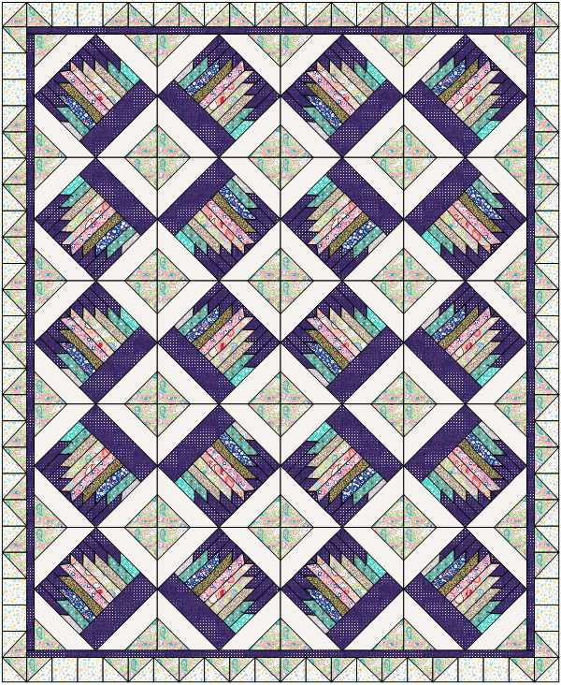

Quilt Sizes 79” square: Use the eight pairs of 4” squares, four single 4” squares, twenty-eight pairs of 4” half square triangles (HST), and eight single 4” HSTs from Part 4.
- Using the picture below (or an arrangement of your own), sew two pairs of 4” squares, seven pairs of 4” HSTs, and two single 4” HSTs together to form a side border; pin and sew to one side of the top. Repeat for the other border. Press toward the outside.
- Sew two pairs of 4” squares, two single 4” squares, seven pairs of 4” HSTs, and two single 4” HSTs together to form the top border; pin and sew to the top. Repeat for the bottom border. Press toward the outside.
Note, if your border doesn’t fit your border correctly (slightly larger or smaller), adjust the size of one or two of the plain squares. If it’s too long, trim the squares as needed; if it’s too long, add a spacer(s) to increase the length.

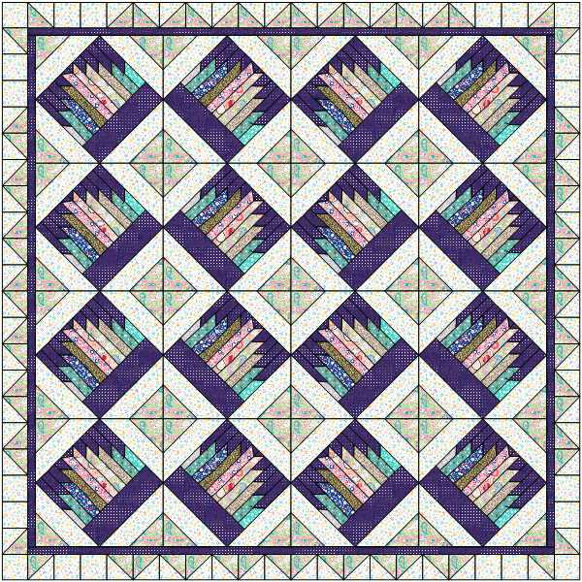

Quilt Size 60.5” x 78”: Use the six pairs of 3 ½” squares, four single 4” squares, eight triplet sets of 3 ½” squares, twenty pairs of 3 ½” half square triangles (HST) , and eight single 3 ½” HSTs from Part 4.
- Sew one more pair of 3 ½”squares ( I miscounted in Part 4).
- Using the picture below (or an arrangement of your own), sew two pairs of 3 ½” squares, two triplet sets of 3 ½” squares, six pairs of 3 ½” HSTs, and two single 3 ½” HSTs together to form a side border; pin and sew to one side of the top. Repeat for the other border. Press toward the outside.
- Sew one pair of 3 ½” squares, two single 3 ½” squares, two triplet sets of 3 ½” squares, four pairs of 3 ½” HSTs, and two single 3 ½” HSTs together to form the top border; pin and sew to the top. Repeat for the bottom border. Press toward the outside.
Note, if your border doesn’t fit your border correctly (slightly larger or smaller), adjust the size of one or two of the plain squares. If it’s too long, trim the squares as needed; if it’s too long, add a spacer(s) to increase the length.

