Pepperell Patchwork Mountains Mystery Quilt
Part 8

Assemble quilt center:
- Lay out the 20 (16, 12) blocks from Part 7 according to one of the layouts shown below or an arrangement of your own.
- Sew blocks together into rows
- Press seams for each row in opposite directions (i.e., row one, press to the right; row two, press to the left, etc.)
- Sew rows together, pressing rows as you desire.

Quilt Sizes 79” x 96.5”:
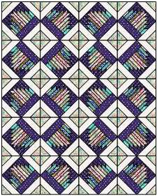
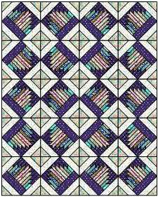

Quilt Sizes 79” square:
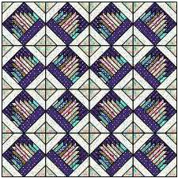
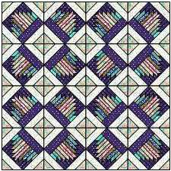

Quilt Size 60.5” x 78”:
