Fusible Covered Bridge Landscape Supply List
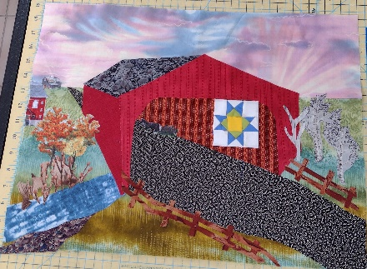
Size: 24” x 18”

Fabric:
Background fabrics – 2 or 3 fabrics, 10” x 25”
Covered bridge:
- Roof – 6” x 9”
- Outside – 9” x 18”
- Inside – 6” x 9”
Road – 6” x 18”
Water – 4” x 8”
Fence – 12” square
Batting – 28” x 22”
Backing - 28” x 22”
Assorted fabrics for ground, trees, background objects such as houses/barns, cars, trains, patchwork quilt

Other Supplies:
- Rotary cutter and mat
- Rulers – 24”; 6” x 12”
- Iron and ironing pad
- Pressing sheet or parchment paper
- Tweezers
- Paper scissors
- Other routine sewing tools, such as small scissors, pins, etc.
- Bag for waste scraps
- Safety pins or fusible spray for layering and basting quilt
- Threads to match your fabrics and/or invisible thread
- Bobbin thread to match your backing
- Sewing machine – ability to do zig zag or decorative stitches is helpful
  - Will be used for piecing and for appliquilting (quilting and sewing down appliques in one step)
  - For quilting:
    - #14/90 needle – quilting needle or topstitch preferred
    - Optional quilting feet – free motion foot/walking foot/stitch regular foot, open toe foot

