Pepperell Patchwork Mountains Mystery Quilt
Part 7

- Sew a large B/D triangle (from Part 3) to one side of 13” square from Part 6.

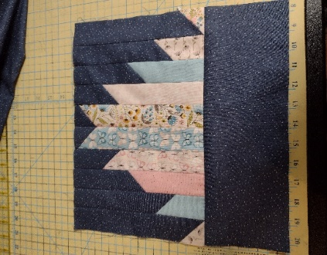
Figure 1 – 13” Square from Part 6

- Sew another B/D triangle to the opposite side of the 13” square. Press outwards toward triangles.

- Sew another B/D triangle to the top of the 13” square.

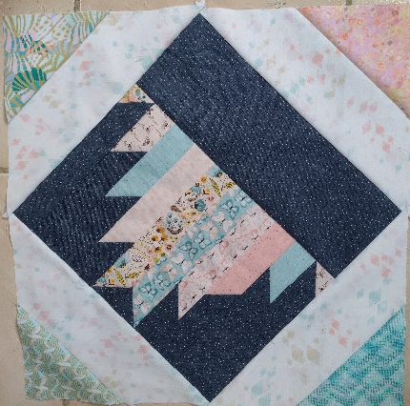
- Sew another B/D triangle to the bottom of the 13” square. Press outwards toward triangles. Square up to 18 ¹/₈” unfinished.

