Pepperell Patchwork Mountains Mystery Quilt
Part 6

- Sew Block A and Block B from Part Five together. Press the seam open, being sure to match up the inner points.
- Square up the block to 8 ¾” x 13” (unfinished).
- Repeat for the remaining blocks for a total of 20 (16, 12) blocks.

Block A Block B
Match inner points
Fabric B
Fabric C

- Sew a 4 ¾” x 13” Fabric C strip to the bottom of Block AB from Part Six.
- Press seam toward Fabric C strip
- Square up the block to 13” square (unfinished).
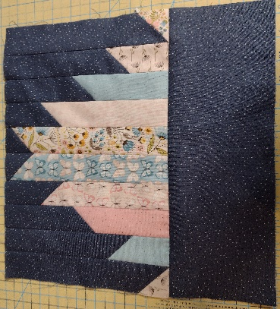
- Repeat for the remaining blocks numbered for a total of 20 (16, 12) blocks.

