Pepperell Patchwork Mountains Mystery Quilt
Part 5

Block A:
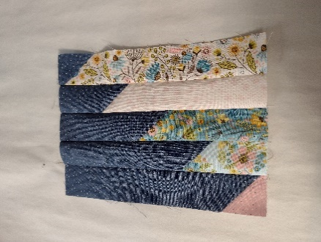
- Select any strip from each of the first five numbered strip bundles/baggies and rearrange them according to the diagram. When choosing the strips, mix up the strips for a variety of fabrics. (If you don’t want a scrappy quilt, use matching fabric strips.)
1 2 3 4 5
Block A
  - Hint: To rearrange the strips easily, start with the original position the strips were cut in and rotate each strip 180º.
- Sew the strips together. Press the seams in the same direction.
- Square up the block to 6 ¾” x 8 ¾” (unfinished).
- Repeat for the remaining strips numbered one to five for a total of 20 (16, 12) blocks.

Block B:
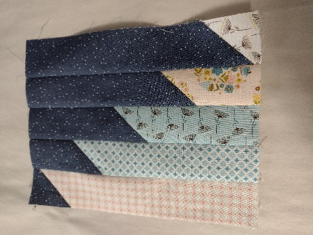
- Repeat the above steps in Block A for the strips numbered from six to ten, arranging the strips according to this diagram for a total of 20 (16, 12) blocks.
6 7 8 9 10
Block B
  - Hint: To rearrange the strips easily, start with the original position the strips were cut in and rotate each strip 180º.

