Techniques Sampler Quilt-Along Assembly Instructions
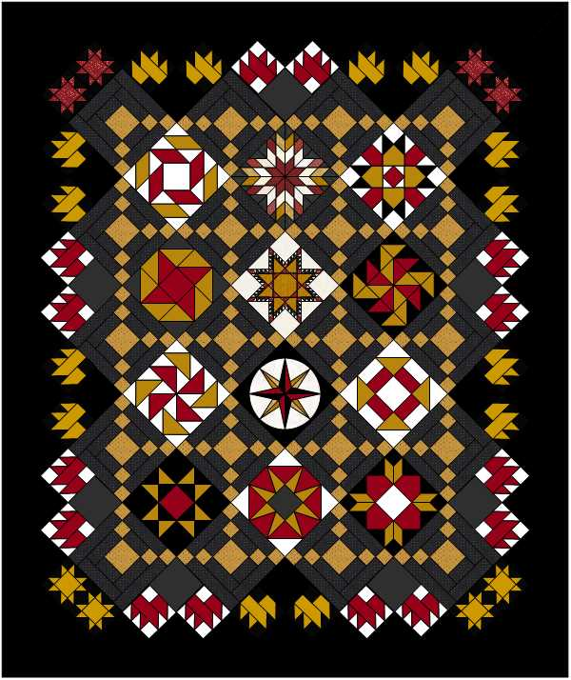
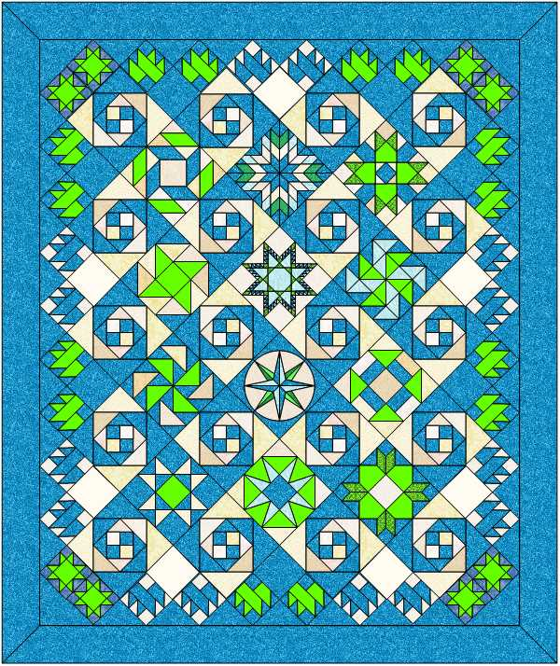
Coloration 1/Design 1 (with borders)

Coloration 2/Design 1 (with borders)

Coloration 1/Design 2 - Irish Chain (with borders)

Techniques: On-point setting; mitered corner borders

Inner Border Cutting Instructions: Note, there are different cutting instructions based on the two different designs (Snail Trail or Irish Chain setting blocks); assembly instructions are the same for both.
Design 1 (Snail Trail Setting Blocks):
Black/blue [A]:
- Cut seven 6 ½” squares
- Cut eight 10” squares; subcut each diagonally two times for a of thirty-two setting triangles
- Cut two 9 ½” triangles; subcut each diagonally once for a total of four corner triangles
White [B]:
- Cut seven 6 ½” squares
Design 2 (Irish Chain setting blocks):
Black/blue [A]:
- Cut fourteen 6 ½” squares
- Cut eight 10” squares; subcut each diagonally two times for a of thirty-two setting triangles
- Cut two 5 ¼” triangles; subcut each diagonally once for a total of four corner triangles
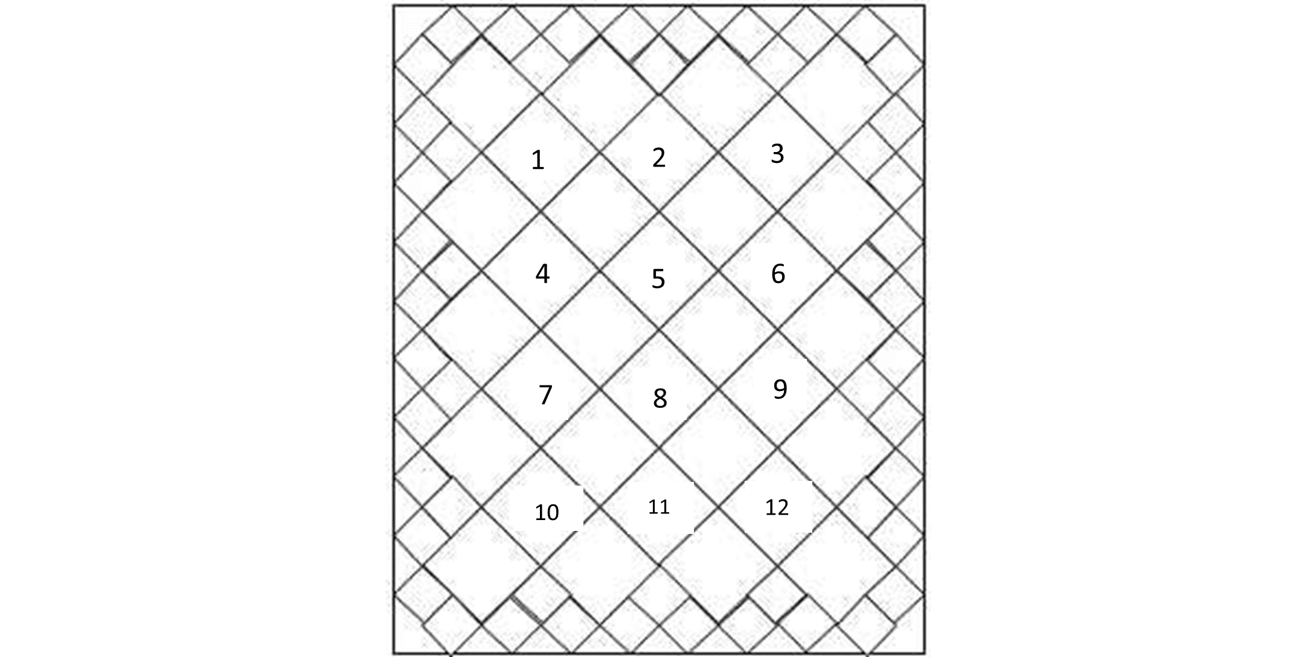
Assembly Instructions (both designs): Referring to the pictures above. arrange the blocks and small quarter setting triangles in diagonal (on-point) rows.
Figure 1
- The small squares are the Maple Leaf block from February, Sawtooh Star block from June, and plain blocks (cutting instructions above).
- The large blank squares are the setting blocks from month June – either the Snail Trail or the Irish Chain blocks.
- Note, there are three different block styles for the Irish Chain setting

- The numbered squares in Figure #1 refer to the following blocks:
  - Mosaic from month May
  - Starburst from month October
  - Providence from month September
  - Ribbon Star from month January
  - Feathered Star from month December
  - Yankee Puzzle from month March
  - Dutchman Puzzle from month March
  - Mariner’s Compass from month November
  - Churn Dash from month February
  - Ohio Star from month April
  - Eight Pointed Star Variation from month April
  - Weathervane from month May
Mitered Borders Cutting Instructions: A mitered corner is when the corners meet at a 45-degree angle, similar to a picture frame. It’s a more challenging border to create, but the picture-perfect angled seam is well worth the effort. It is especially effective with certain fabrics, such as border prints or stripes, making them go around the corners in a circular fashion.
Determine Length of Borders: Note, if using a border fabric or stripes, it’s best to use a single length of fabric; if piecing, try to carefully match the fabric design.
Formula to find how long each border piece needs to be:
- Length of quilt side(s): measure the unfinished length of the quilt’s sides (width and length for rectangular quilt) to which the border will be sewn.
- Width of the border multiplied by 2: measure the unfinished width of your border and multiply by two.
- Add 6 inches: this includes the extra fabric needed for the mitered corner on each side of the border, plus the seam allowance.
Here is the formula for this sampler with the numbers plugged in.
- Quilt width = 76.5 Quilt length = 93.5
- Width of the border x2 = 6.5 x 2 = 13 Width of the border x2 = 6.5 x 2 = 13
- Plus 6” Plus 6”
- Size of top and bottom borders: 95.5” Size of side borders: 112.5”

Construction Instructions:

Sew the Borders in Place:
- Fold the borders and quilt sides in half, marking each center. Line the centers up and pin them together. It doesn’t matter which order to attach the borders.
- Measure and mark the length of a border to match the exact length of the applicable quilt side. Align the quilt side and border, then pin the centers together.
¼” marks
Figure 2
- Next, make a mark on either end of the border ¼” in from the edge of the quilt (Figure #2).
- Sew the border to the quilt, starting and stopping at the ¼” marks, backstitching at the beginning and end of these seams to secure the stitches.
  - Important: Leaving the ¼” ends unsewn is extremely important, so if you accidentally sew beyond the marks, be sure to take out those stitches.
  - Press seam toward the border.
  - Repeat these steps to attach the remaining borders to the quilt.

Fold the quilt diagonally, mark and sew mitered corners:
  - Fold the quilt top in half diagonally, right sides together, creating a triangle.
  - Line up two neighboring borders, like the top border and one side border (Figure #3).
  - Line up the side of the ruler with the fold and align the 45-degree angle on the ruler along the edge of the border, extend it across the borders beyond the quilt edges. Mark a line along the ruler side onto the border and pin firmly in place (Figure #3) .
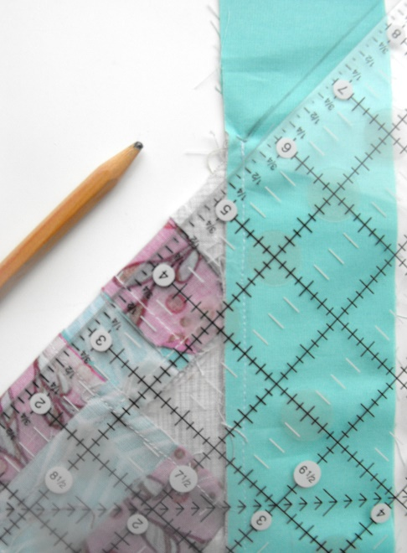
- Locate the stitched seam you made when you sewed the border to the quilt top and begin sewing from the ¼” mark out toward the opposite side of the border, directly on the marked line. This will ensure there are no gaps or spaces. Backstitch at the beginning and end. Unfold your quilt top and make sure there are no gaps in the inner corner and that the border lies flat.
Figure 3
Ruler Edge
45-degree line
Marked Line
Aligned Borders
- Trim the excess border to ¼” and press seam open.
- Repeat for the other corners.
Here is a video, which clearly demonstrates the process:
(1) How to Miter Borders on a Quilt
Pieced Borders Cutting Instructions:
Black/blue [A]:
- Cut ten 6 ½” strips for pieced borders

Construction Instructions:
- Sew the strips together, using a mitered seam to decrease the amount of bulk in the seams.
- To determine the length of the side borders, measure the quilt three times across the width of the quilt and average the three measurements together to determine the length to cut both side border strips.
- Cut two strips according to your measurements for the side borders.
- Fold the borders and quilt sides in half, marking each center. Line the centers up and pin them together.
- Sew seams and press seams toward borders.
- To determine the length of the top and bottom borders, measure the quilt three times across the length of the quilt and average the three measurements together to determine the length to cut the top and bottom border strips.
- Cut two strips according to your measurements for the top and bottom borders.
- Fold the borders and quilt sides in half, marking each center. Line the centers up and pin them together.
- Sew seams and press seams toward borders.

