Pepperell Patchwork Mountains Mystery Quilt
Part 4

Pat 4A:
- Lay out a matched pair of sewn HSTs from Part Two as shown in the diagram.

- Cut each HST into five 1¾” strips – the cut strips from each of the two HSTs
1 2 3 4 5
6 7 8 9 10
will be the reverse of each other.

- Label/bundle together the strips from each cut up HST (or place in baggies) numbered
according to the diagram.
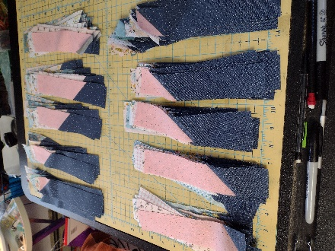
- Repeat for the remaining 20 (16, 12) HST pairs, labeling/placing the strips into the same bags as the first two HSTs.
1 2 3 4 5
6 7 8 9 10

Here are the bundles of my strips:

Part 4B: Note: This section has different instructions for the various sizes of quilts, so follow the directions for the appropriate size quilt.

Quilt Sizes 79” x 96.5”:
- Sew two 4” Fabric D squares together.

- Repeat, sewing fourteen more 4” squares, for a total of eight pairs.

- Sew two of the 4” B/D HSTs from Part Three together.
(Note: These are not the same HSTs as in Part 4A but are the smaller corners that were constructed in Part Three.)

- Repeat, sewing sixty-two more 4” squares, for a total of thirty-two pairs.
- There will be sixteen more HSTs left over – they will be used later.

Quilt Sizes 79” square:
- Sew two 4” Fabric D squares together.

- Repeat, sewing fourteen more 4” squares, for a total of eight pairs.
- There will be four more 4” squares left over – they will be used later.

- Sew two of the 4” B/D HSTs from Part Three together.
(Note: These are not the same HSTs as in Part 4A but are the smaller corners that were constructed in Part Three.)

- Repeat, sewing fifty-four more 4” squares, for a total of twenty-eight pairs.
- There will be eight more HSTs left over – they will be used later.

Quilt Size 60.5” x 78”:
- Sew two 3 ½” Fabric D squares together.

- Repeat, sewing ten more 3 ½” squares, for a total of six pairs.

- Sew three 3 ½” Fabric D squares together.

- Repeat, sewing twenty-one more 3 ½” squares, for a total of eight triplet sets.
- There will be four more 3 ½” squares left over – they will be used later.

- Sew two of the 3 ½” B/D HSTs from Part Three together.
(Note: These are not the same HSTs as in Part 4A but are the smaller corners that were constructed in Part Three.)
- Repeat, sewing thirty-eight more 3 ½” squares, for a total of twenty pairs.

- There will be eight more HSTs left over – they will be used later.

