Month 12 (December): Feathered Star 12"
Feathered Star - 12"
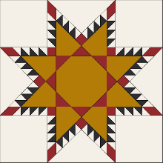
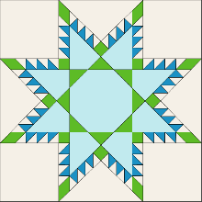
Fabric Keys:
Black = A Blue = A
Gold = C Light blue = C
Red = D Green = D
History: This block dates to the late 1800’s A Feathered Star quilt block is ideal for medallion style quilt. It is basically a LeMoyne Star, adding an outline of small triangles to the star block. The center can showcase some intricate piecing or just be a simple plain square. The complexity of the block meant only seasoned quilters would attempt it to showcase their skills and would use their best fabrics. As a result, these quilts were rarely used as utility quilts. They were put away and preserved, which is why there are a lot of really nice, antique feathered star quilts today.
Techniques: Half square triangles (HSTs) using a bias strip piecing method; partial seams
Supplies: Square ruler with ¹/₈” markings (at least 6 ½”) or Bias Square ruler (optional) or Marsha McCloskey’s Feathered Star ruler (optional); baggies or other container for sorting small pieces; starch/Best Press; tweezers (optional); small flannel/board to lay out pieces (optional)
Cutting Instructions: Figure #1 shows the pieces of the star and their names to make it easier to know which fabrics to cut for each part. Note that the colors are different just to make it easier to read.
Note:
- Use starch/Best Press on your fabrics before cutting. Some of the pieces are small fractions – do the best you can.
- For best organization, label pieces with their highlighted names and store in baggies.

Black/blue [A] and White [B]:
- Layer black/blue [A] and white [B] fabrics, right sides together (RST) and cut a 10” square from them for the feather half square triangles (HSTs)
White [B]:
- Cut a 1 ½” x 12” strip; subcut eight 1 ½” squares, then cut each square diagonally once to yield sixteen half triangles for the feather triangles at the sides of the star points.
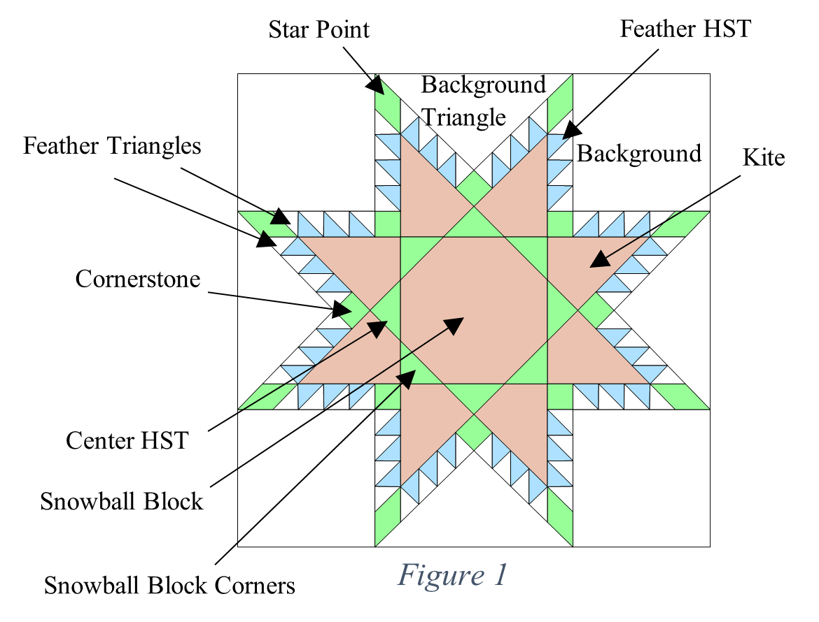
- Cut four 4 ½’ squares for background corners
- Cut one 6 ½” square; subcut diagonally twice for background triangles
Gold/ light blue [C]:
- Cut one 4 ¼” square for center snowball block
- Cut four 3 ½” squares; subcut in half diagonally; these will be used to make the kites.
Red/green [D]:
- Cut one 1¹/₈” strip; subcut eight 1 ¹/₈” squares for cornerstones; save remainder of strip for the star point diamonds.
- Cut four 1⁷/₈” squares for the snowball block corners
- Cut one 2 ¾” square; subcut diagonally twice to yield four quarter square triangles for Center HSTs

Additional Detailed Cutting Instructions:

Star Points:
- Fold the red/green [D] 1¹/₈” strip in half RST, end to end
- Line up your ruler so the 45º line is parallel with the bottom edge of the strip and cut along the side of the ruler (Figure #2).
- Line up your ruler with the cut edge and subcut four 1¹/₈” sections parallel to the previous cut (Figure #3). Since the strip is folded, this will yield eight diamonds: four will be a mirror image of the other four. Label the four diamonds from the top strip star point #1 and those from the bottom strip star point #2 (Figure #4).
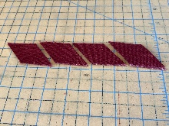
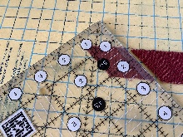
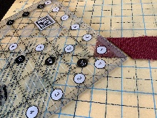
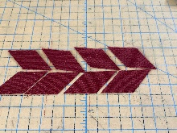
Note: The strips are on the bias, so be careful when handling the strips as they could stretch.
Figure 3
Figure 2
Figure 4
Star Point #1
Star Point #2

Kites:
- Using a gold/light blue [C] 3 ½” kite triangle, measure the length of the square down the long side of the triangle, in this case 3 ½” . You can see the kite shape underneath the ruler (Figure #5).
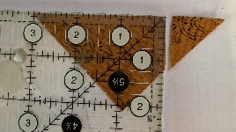
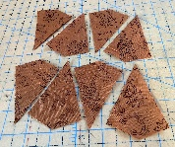
- Cut off the protruding triangle (Figure #6). Repeat for the other seven kite triangles for a total of eight kites.
Figure 5
Figure 6

Construction: Accuracy is important, so be sure to have a good ¼” seam.

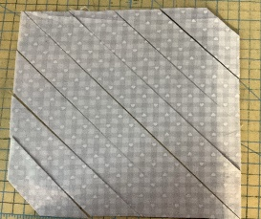
Feather Half Square Triangles (HSTs): The Bias Strip Piecing a technique that keeps the straight of grain on the outside edge, which allows pieces to be very accurate and stable, and helps everything go together well.
Figure 7
- Using the layered Black/blue [A[ and white [B] 10” squares, cut the square diagonally from corner to corner. Then make 1 ½” wide cuts in both directions until you have cut the entire square. Discard the two small end triangles (Figure #7).
- Sew the layered strips together along the longest edges, going from the longest center strips, then the strips on either side of the center ones, out toward the smallest ones, forming one continuous bias strip. Press seams open (Figure #8).
- Line up a corner of a square ruler on the bottom of an end bias strip and cut a 1¼”feather HST, aligning the ruler’s 45º line with the seam line. Always cut them from the lowest point (Figure #9).
- Rotate the block and trim to 1¹/₈“ size (Figure #10).
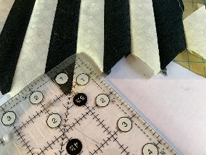
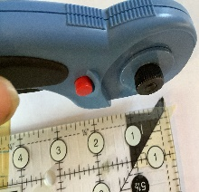
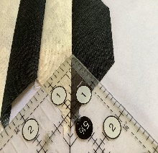
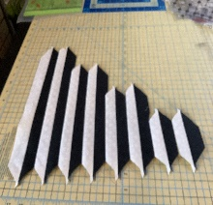
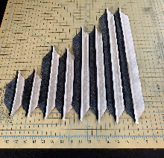
- Make a total of forty-eight feathers.
Figure 8
Figure 9
Figure 10

Corner Blocks:
Star Point #1
Figure 11
Feather Triangle
Star Point #2
- Figure #11 shows the layout for one of the corner blocks.
- Sew the red/green [D] diamond star point #2 and the white [B] feather triangle first RST. Match the narrow tip of the diamond to the narrow angle of the triangle.
- Press seam open. Trim off “bunny ears.”
- Sew three 1¹/₈“ feather HSTs from the previous section together for the left side; be sure to orient the direction of the triangles correctly. Press seams open.
- Sew the HSTs strip to the diamond star point #2/triangle section. Press seam open.
- Sew this unit to the left side of a white [B] 4 ½” background corner square. Press seam toward large background corner square.
- Make another one of these units for the bottom side, noting the different orientation of the pieces and adding a 1¹/₈“ red/green [D] cornerstone square to the opposite end of the unit from the star point. Press all seams open.
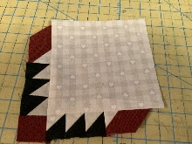
- Sew unit to bottom of feather/square unit, matching and pinning the corner seams. Press seam toward large corner square. The background corners should extend out beyond the tips of the star points (Figure #12).
Figure 12
- Make three more blocks for a total of four blocks.
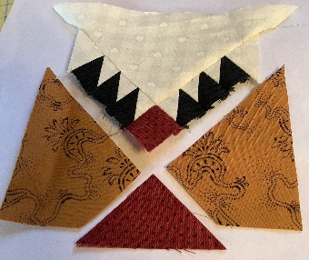
Figure 13
Triangle/Feather/Kite Units:
- Figure #13 shows the layout for one of these units.
Feather Triangle
Figure 14
- Figure #14 shows the layout for the first subunit - the triangle/feather section.
- Sew three feather HSTs and a feather triangle into a strip as in the corner units above, noting the orientation of the pieces.
- Sew a second strip with the cornerstone added to the end.
- Press all seams open.
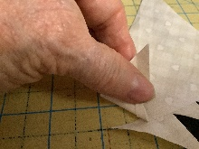
- Sew the feather strip without the cornerstone to the large [D] side white triangle with a partial seam: stop sewing about halfway down the side of the end feather triangle; back stitch to secure. In figure #15 the feather triangle is pulled up to see where to stop sewing. Note that the large triangle will extend out beyond the feather strip by about one inch.
Figure 15
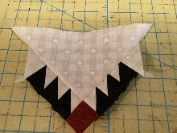
- Press seam toward large triangle. Trim off “bunny ears.”
Figure 16
- Sew the other feather HSTs strip to the other side of the large side triangle with another partial seam, matching and pinning the corner seams. Press seam toward large triangle (figure #16).

- The next step is to make the kite section and attach it to the triangle/feather subunit. Sew a red/green [D] Center HST to one of the gold/light blue [C] kite pieces RST, aligning the short sides of the triangle and kite and their right angles. Press seam toward the kite piece (Figure #17).
- Align and sew the other kite piece onto the triangle/feather strip RST (Figure #18). Press toward the kite piece.
- Nest, pin and sew the kite/Center HST /piece to the large side triangle/kite unit RST with the tips of the central HST and cornerstone pieces touching. Press to the kite piece (Figure #19). Cut off all “bunny ears.”
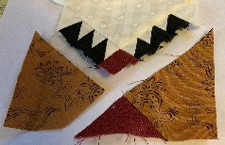
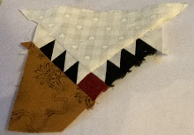
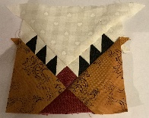
- Repeat making three more triangle/feather/kite sections for a total of four units.
Figure 17
Figure 18
Figure 19

Snowball Unit:
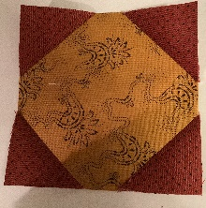
- Sew four 1⁷/₈” red/green [D] squares on each corner of the 4 ¼” gold/light blue square, using a sew and flip technique. Sew diagonally across each small square. Sew from corner to corner, sewing just a thread or two to the right, so the small square will cover the whole corner when pressed open. If you line up the left side of the presser foot with the corner, go slow and keep your eye on your destination (the other corner), and keep your eye on your destination, you will sew right to it. You can draw a line on your square with a pencil if that will help you sew straight.
Figure 20
- Sew all four corners in the same way.
- Press open toward the corners. Trim the under layers of the corners to ¼”.
- Trim snowball unit to 4 ¼” (Figure #20).

Assemble Blocks:
Figure 21
- Figure #21 shows the three blocks for the top (and bottom) row.
- Pin the unsewn corners from the partial seam on the triangle/feather/kite section so they don’t get in the way (Figure #22).
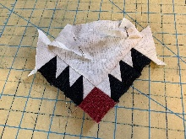
- Align, pin and sew one corner section to the side of the triangle/feather/kite, matching the star point of the corner section to the intersection of the feather triangle and kite (Feather #23).
Figure 22
- Press seam toward center section.
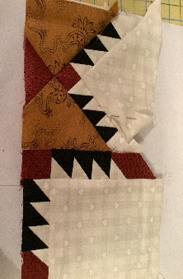
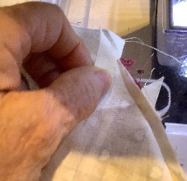
- Unpin and smooth out the unsewn portion of the partial seam. Sew down, backstitching where the previous partial sea ended (Figure #24) . Press remainder partial seam toward center section.
Figure 23
Match points
Figure 24
- Join the other corner section in the same way.
- Repeat above to make the bottom row.

- For the middle row, sew the outside triangle/feather/kite sections to the center snowball unit, matching and pinning the points (Figure #25). Press toward triangle/feather/kite unit.
- To sew the rows together, there are more partial seams.
- Fold the unsewn triangle corner down to pin it out of the way.
- After you get the partial seam out of the way, sew the seam. There will be a small “bunny ear” extending at the end.
- Now finish the partial seam, lining up the point of the partial seam triangle with the bunny ear. The corner square will still look large, extending past the star point (Figure #26).
- Sew the bottom row to the two top rows.
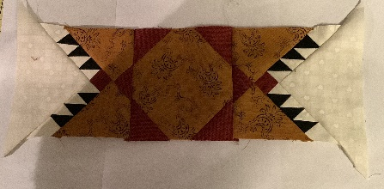
- Square up the finished block to 12 ½ inches (Figure #27).
Match points
Figure 25
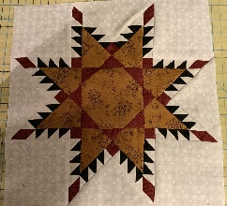
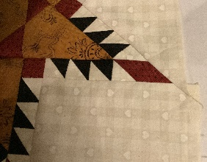
Figure 25
Figure 26

