NOTES: Width of fabrics (WOF) for this pattern is assumed to be 40”. A scant ¼” (a thread width smaller than ¼”) seam is to be used throughout the construction of the quilt unless otherwise instructed.

Fabric Requirements
The Meadow Mystery quilt is a lap sized quilt containing 5 different fabrics in the quilt top:

Fabric Selection Tips
Finished Siz
e

60
½
” x 60
½
”
Fabric A
- Medium
Value Fabric
½
yd
Fabric B
- Dark Value Fabric
¾ yd
Fabric C
- Dark Value Fabric
yd
1
Fabric D
- Light to Medium
Value Fabric
1
yd
Fabric E
- Light Value Fabric
2
¼ yds
Binding Fabric
⅝ yd
Backing Fabric (with 4” overhang)
3

⅞
yds
Batting
” x 70”
70
- Within this quilt pattern, the following colors will be used to represent the fabrics:
A |  | B |  | C |  | D |  | E
- Due to the finished fabric piece sizes and piecing methods for the quilt top, it is recommended that fabric prints used have a smaller scale, non-directional design.
- Each of the fabric yardages above may be made using scraps of similar colors instead of a single fabric. • The following fabrics will be next to each other, please test your fabrics selections to make sure that there is a good amount of contrast between the fabrics:
- A is next to B, C, and E
- B is next to A, D, and E
- C is next to A, D, and E
- D is next to B and C
- E is next to A, B, and C
- E can be considered the main background of the quilt and D can be considered a secondary background of the quilt.
- So that the eye has a place to rest within the quilt, it is suggested that a solid or a tone-on-tone print that reads as a solid be used for Fabric E.
- It is helpful to create a sheet with your chosen fabrics and the corresponding pattern letters. This will help remind you of which fabric goes with which instructions as the quilt along progresses.

Cutting Instructions
If you like to oversize and then trim down your half square triangles (HSTs), flying geese, and square in a square units then oversize the pieces indicated with a * by about ¼”.

FABRIC A
1. Cut 4 strips * 3" x WOF.
a. Sub-cut the strips into 48 squares 3” x 3” (each strip can yield 13 squares* ).

FABRIC B
- Cut 2 strips * 5 ½" x WOF.
  - Sub-cut the strips into 12 squares 5 ½” x 5 ½” (each strip can yield 7 squares* ).
- Cut 1 strip * 5 ¼" x WOF.
  - Sub-cut the strip into 4 squares 5 ¼” x 5 ¼”.*
- Cut 2 strips 2 ½” x WOF. Do not sub-cut the strips.

FABRIC C
- Cut 1 strip 5 * ½” x WOF.
  - Sub-cut the strip into 2 squares 5 ½” x 5 ½” and 4 squares 5” x 5”.* *
- Cut 3 strips * 5" x WOF.
  - Sub-cut the strips into 24 additional squares 5” x 5” (each strip can yield 8 squares* ).
- Cut 1 strip 4 ½" x WOF.
  - Sub-cut the strip into 16 rectangles 2 ½” x 4 ½”.

FABRIC D
- Cut 1 strip 5 * ½” x WOF.
  - Sub-cut the strip into 4 squares 5 ½” x 5 ½” and 4 squares 4 ½” x 4 ½”.*
- Cut 3 strips * 5" x WOF.
  - Sub-cut the strips into 24 squares 5” x 5” (each strip can yield 8 squares* ).
- Cut 1 strip 4 ½" x WOF.
  - Sub-cut the strip into 8 additional squares 4 ½” x 4 ½”.
- Cut 1 strip 2 ½” x WOF. Do not sub-cut the strip.

FABRIC E
- Cut 2 strips 5 * ½” x WOF.
  - Sub-cut the strips into 10 squares 5 ½” x 5 ½” (each strip can yield 7 squares* ).
- Cut 4 strips * 5" x WOF.
  - Sub-cut 3 strips into 24 squares 5” x 5” squares (each strip can yield 8 squares* ).
  - Sub-cut 1 strip into 4 additional squares 5” x 5” and 1 square 4 ½” x 4 ½”.*
- Cut 7 strips 4 ½" x WOF.
  - Sub-cut the strips into 56 additional squares 4 ½” x 4 ½” (each strip can yield 8 squares).
- Cut 2 strips 3 ⅜” x WOF.
  - Sub-cut each strip into 3 ⅜” x 3 ⅜” squares (11 per strip) to yield a total of 16 squares 3 ⅜” x 3 ⅜”.
- Cut 1 strip 2 ½” x WOF. Do not sub-cut the strip.

Half Square Triangle Units
Combine the following fabric squares to form Half Square Triangle Units (HST units) using the method outlined below:
16 Fabric C squares (5” x 5”) and 16 Fabric D squares (5” x 5”) to form 32 C/D HST Units (4 ½” x 4 ½”). 12 Fabric C squares (5” x 5”) and 12 Fabric E squares (5” x 5”) to form 24 C/E HST Units (4 ½” x 4 ½”).
- Place the squares (5” x 5”) right sides together. Draw a diagonal line using a removable marking device on the back of the lighter square (shown as the solid line).
- Sew ¼” on either side of the solid line (shown as the dotted lines). Cut on the solid line and press seams open or toward the darker fabric.
- Trim each HST unit to (4 ½” x 4 ½”).
- Repeat to form 32 C/D HST Units and 24 C/E HST Units (4 ½” x 4 ½”).
4

¹⁄”

4
¹⁄”

4
¹⁄”
4

¹⁄”
4

¹⁄”

4
¹⁄”
4

¹⁄”
4

¹⁄”
C/D HST Units C/E HST Units

Block 6
Arrange and sew together the following fabric pieces as listed and shown below, pressing all seams open. Block 6 should measure 12 ½” x 12 ½”. Repeat to form a total of 4 blocks.
8 C/D HST (4 ½” x 4 ½”)
1 Fabric D square (4 ½” x 4 ½”)

Block 6

Hourglass Units and Half Hourglass Units

1. HALF SQUARE TRIANGLE UNITS
Combine the following fabric pieces to form HST units using the HST instructions shown previously:
4 Fabric B squares (5 ½” x 5 ½”) and 4 Fabric D squares (5 ½” x 5 ½”) to form 8 B/D HST Units (5” x 5” approx.).
8 Fabric B squares (5 ½” x 5 ½”) and 8 Fabric E squares (5 ½” x 5 ½”) to form 16 B/E HST Units (5” x 5” approx.).
2 Fabric C squares (5 ½” x 5 ½”) and 2 Fabric E squares (5 ½” x 5 ½”) to form 4 C/E HST Units (5” x 5” approx.).
Do NOT trim the HST Units at this point.
(There is no need to trim these HST Units as they are just intermediate units to be used in making the half and full hourglass units below. The half and full hourglass units will be trimmed when complete. In the directions below, the HST will be marked with a size of 5” x 5” approx. as they are not trimmed.)

2. HALF HOURGLASS UNITS
Combine the following fabric pieces to form the Half Hourglass Units using the method outlined below:
8 B/D HST Units (5” x 5” approx.) and 8 Fabric D squares (5” x 5”) to form 16 B/D Half Hourglass Units (4 ½” x 4 ½”).
14 B/E HST Units (5” x 5” approx.) and 14 Fabric E squares (5” x 5”) to form 28 B/E Half Hourglass Units (4 ½” x 4 ½”).
2 C/E HST Units (5” x 5” approx.) and 2 Fabric E squares (5” x 5”) to form 4 C/E Half Hourglass Units (4 ½” x 4 ½”).
- Place a HST Unit (5” x 5” approx.) and a fabric square (5” x 5”) right sides together. Draw a diagonal line using a removable marking device on the back of the HST Unit (shown as the solid line) perpendicular to the seam.
- Sew ¼” on both sides of the solid line (shown as the dotted lines). Cut on the solid line and press seams open.
- Trim half hourglass blocks to 4 ½” x 4 ½”.
Notes: Each set of one square and one HST Unit will yield two half hourglass blocks.
Do not worry about the orientation of the seam within the D and E fabrics in the half hourglass units.
=
4
½”
4
½”
4
½”
½”
4
B/D Half Hourglass Units
=
4
½”
4
½”
4
½”
4
½”
=
4
½”
½”
4
4
½”
4
½”
B/E Half Hourglass Units C/E Half Hourglass Units

3. FULL HOURGLASS BLOCKS
Combine the following fabric pieces to form the Full Hourglass Units using the method outlined below:
2 B/E HST Units (5” x 5” approx.) and 2 C/E HST Units (about 5” x 5”) to form 4 B/C/E Full Hourglass Units (4 ½” x 4 ½”).
- Place a B/E HST Unit (5” x 5” approx.) and a C/E HST Unit (5” x 5” approx.) right sides together such that the seams on the HST Units are aligned (and the E fabrics are on opposite sides of the seam from one another). Draw a diagonal line using a removable marking device on the back of the one of the HST Units (shown as the solid line) perpendicular to the seam of that HST Unit.
- Sew ¼” on both sides of the solid line (shown as the dotted lines). Cut on the solid line and press seams open.
- Trim full hourglass blocks to 4 ½” x 4 ½”. Note: each set of two HST Units will yield two full hourglass blocks.
=
4
½”
4
½”
4
½”
4
½”
B/C/E Full Hourglass Units

Flying Geese Units
Combine the following fabric squares to form Flying Geese Units using the No Waste Flying Geese method outlined below (1 Fabric B square and 4 Fabric A squares will yield 4 flying geese units):
4 Fabric B squares (5 ¼” x 5 ¼”) and 16 Fabric A squares (3” x 3”) to form 16 Flying Geese Units (2 ½” x 4 ½”).
- Place 2 of the Fabric A squares (3” x 3”) on opposite corners of a Fabric B square (5 ¼” x 5 ¼”) right sides together. (The Fabric A squares will overlap in the middle of the Fabric B square.) Use a removable marking device to make a line diagonally across the Fabric A squares (solid line).
- Sew scant ¼” seam on either side of the marked line (dotted lines) and then cut on the marked line (solid line).
- Press seams towards the Fabric A squares. (You will have two of these intermediate units.) For each intermediate unit, place a Fabric A square (3” x 3”) on the corner the Fabric B square right sides together. Draw a diagonal line on the Fabric A square (solid line) and sew a scant ¼” on either side of the marked line (dotted lines).
- Cut on the marked line (solid line) and press seams open or towards the Fabric A squares. (Each set of 1 Fabric B square and 4 Fabric A squares will yield 4 flying geese.)
Repeat to form a total of 16 Flying Geese Units. Cut off tabs (also known as dog ears) and trim blocks to 2 ½” x 4 ½” if necessary, making sure there is ¼” between the point of the goose triangle and the edge of the unit.

Square in a Square Units (SiaS Units)
Combine the following fabric pieces to form Square in a Square (SiaS) Units using the method outlined below:
16 Fabric E squares (3 ⅜” x 3 ⅜”) and 32 Fabric A squares (3” x 3”) to form 16 Square in a Square (SiaS) Units (4 ½” x 4 ½”).
- Cut each Fabric A square (3” x 3”) in half once diagonally to form 64 Fabric A triangles (3” x 3”).
- Center a Fabric A triangle (3” x 3”) along one side of a Fabric E square (3 ⅜” x 3 ⅜”) right sides together. Sew along the edge with a scant ¼” seam (shown as a dotted line), pressing seam open or outwards.

- Sew another Fabric A triangle (3” x 3”) on the side of the square opposite to the first seam, pressing seam open or outwards. (Note: you can sew both of these triangles on then press instead of pressing after each addition.)

- Continue by sewing two more Fabric A triangles onto the remaining outside edges of the square, pressing seams open or outwards.

- Trim off the tabs (dog ears) formed by the sewn on triangles and square the unit to 4 ½” x 4 ½” (if necessary) making sure there is ¼” between the corner of the inner square and the outer side of the unit. Repeat to form a total of 16 SiaS units (4 ½” x 4 ½”).

Block 1
Arrange and sew the following fabric pieces as listed and shown below, pressing all seams open. Block 1
should measure 12 ½” x 12 ½”. Make 1 block.
- B/C/E Full Hourglass Units (4 ½” x 4 ½”)
- Fabric E squares (4 ½” x 4 ½”)
Block 1
Block 3
Arrange sew the following fabric pieces as listed and shown below, pressing all seams open. Block 3 should measure 12 ½” x 12 ½”. Repeat to form a total of 4 blocks. Note: Do not worry about the orientation of the seams in the B/E half hourglass units.
2 B/E Half Hourglass Units (4 ½” x 4 ½”)
2 C/E HST Units (4 ½” x 4 ½”)
Block 4
Fabric E squares (4
5
½” x 4 ½”)
Block 3
Arrange and sew the following fabric pieces as listed and shown below, pressing all seams open. Block 4 should measure 12 ½” x 12 ½”. Repeat to form a total of 4 blocks. Note: Do not worry about the orientation of the seams in the B/E and C/E half hourglass units.
2 C/E HST Units (4 ½” x 4 ½”)
1 B/E Half Hourglass Units (4 ½” x 4 ½”) 1 C/E Half Hourglass Units (4 ½” x 4 ½”)
5 Fabric E squares (4 ½” x 4 ½”)

Block 4

Block 2
Arrange and sew the following fabric pieces as listed and shown below, pressing all seams open. Block 2
should measure 12 ½” x 12 ½”. Repeat to form a total of 4 blocks.
4 SiaS Units (4 ½” x 4 ½”)
4 A/B Flying Geese Units (2 ½” x 4 ½”)
Block 5
Fabric C rectangles (2
4
½” x 4 ½”)
Fabric E square (4
1
½” x 4 ½”)
Block 2
Form 1 B/D strip set by sewing a Fabric B strip (2 ½” x WOF) to a Fabric D strip (2 ½” x WOF), pressing the seam open. Cut the B/D strip set into 16 B/D Strip Units (2 ½” x 4 ½”). (Cut carefully as you will be using almost the entire WOF of the strip set.)
2 ½”
4  ½  ” | B  D
Form 1 B/E strip set by sewing a Fabric B strip (2 ½” x WOF) to a Fabric E strip (2 ½” x WOF), pressing the seam open. Cut the B/E strip set into 16 B/D Strip Units (2 ½” x 4 ½”). (Cut carefully as you will be using almost the entire WOF of the strip set.)
2 ½”
B
E
4

½
”
Arrange and sew the following fabric pieces listed and shown below, pressing all seams open. Block 5 should measure 12 ½” x 12 ½”. Repeat to form a total of 8 blocks.
2 B/D Strip Units (2 ½” x 4 ½”)
2 B/E Strip Units (2 ½” x 4 ½”)
2 B/D Half Hourglass Units (4 ½” x 4 ½”)
2 B/E Half Hourglass Units (4 ½” x 4 ½”)
1 C/E HST Unit (4 ½” x 4 ½”)
1 Fabric D square (4 ½” x 4 ½”)
1 Fabric E square (4 ½” x 4 ½”)

Block 5

Quilt Top Assembly
Assemble the quilt top using the following Blocks (each 12 ½” x 12 ½” unfinished):

(1) Block 1 (4) Block 2 (4) Block 3 (4) Block 4 (8) Block 5 (4) Block 6
Arrange the blocks as shown below, rotating the blocks to match the following diagram. Sew blocks into rows then sew rows together, pressing all seams open. The quilt top should measure 60 ½” x 60 ½”.
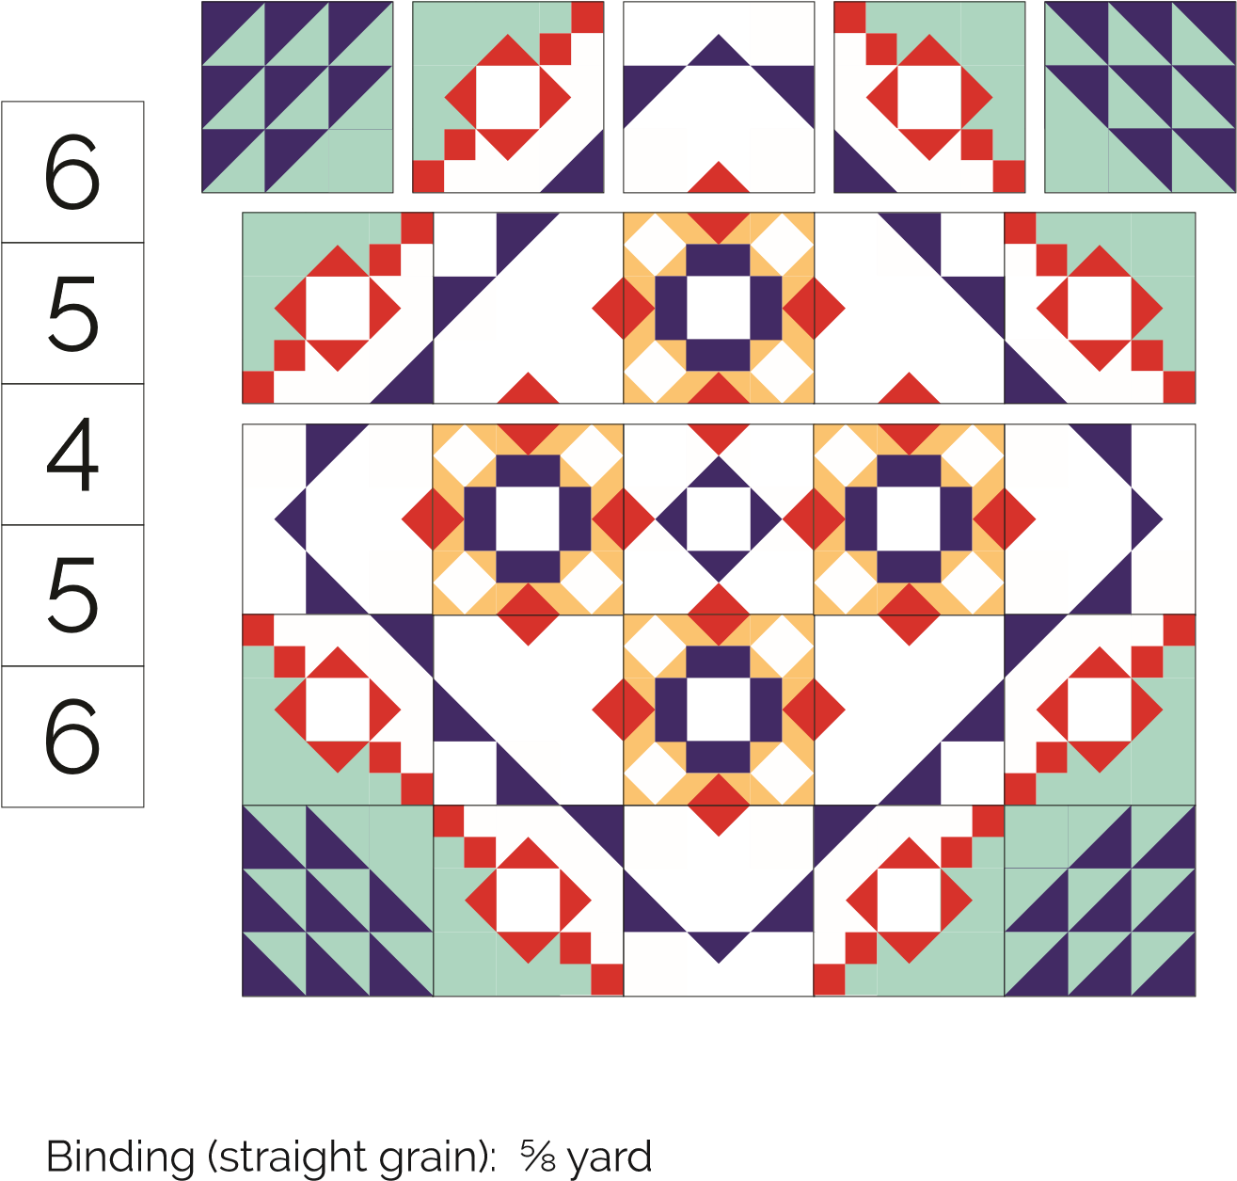
6 5 4 5 5 3 2 3 4 2 1 2 5 3 2 3
6 5 4 5

Finishing
Backing: 3 ⅞ yards
Batting: 70” x 70”
- Remove selvages from backing fabric, cut into 2 pieces (70” x WOF) and sew backing pieces together along the trimmed selvage edges using a ½” seam, pressing seams open. Trim backing to approx. 70” x 70”.
- Layer the quilt top, batting, and backing. Baste and quilt as desired.
- Cut the binding fabric into 7 strips 2 ½” x WOF. Trim off selvages and sew together end-to-end to make the binding. Bind and enjoy your quilt!

Share Your Quilt
You can share your in-progress and finished pictures of your mystery quilt on the Meadow Mist Designs’ Facebook group: www.facebook.com/groups/1583320305263906/ and on Instagram and other social media using #MeadowMistDesigns and #MeadowMysteryQuilt.
MEADOW MYSTERY QUILT

