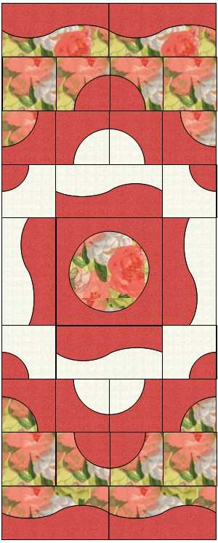
Curves and Circles Workshop
Table Runner: Size: 24” x60”

Block Sizes:
Center medallion: 12”
Center borders (4): 6” x 12”
Blocks (20): 6” x 6”
Outer borders (2 – top and bottom): 24” x 6”
Description:
This is a techniques workshop, focusing on four different techniques for machine sewing curves and circles: insetting circles (center medallion); improvisational curves, including cutting and sewing pieced gently curved blocks; gentle curves (Drunkard’s Path blocks); and faux scallop edges (borders).
General Supplies:
- Sewing machine in good condition with the ability to sew a ¼” seam (1/4” foot if available), threaded with a neutral cotton thread in both top and bobbin.
- Open toe foot for applique (optional)
- Thread for sewing applique on the borders – contrast or matching inner fabric (floral fabric in sample) – can also use a decorative thread
- Double sided fusible with paper backing – 24” (i.e. light or regular Steam a Seam II, Heat n’ Bond Feather Lite, Pellon Wonder Under); include usage instructions
      - OR
  - Fusible basting spray and freezer paper (i.e. K2000 or 505)
- Rotary cutter (new or good blade)
- Cutting ruler(s) for cutting blocks listed above
- Cutting mat
- Usual sewing supplies (scissors, pins, extra machine needles and bobbins, seam ripper, etc.)
- Pencil or marking pen
Optional Recommended Supplies:
- Iron and small pressing surface

Fabric Requirements (for quilt as pictured):
Focus Fabric– 1 yard (This is the floral fabric in the picture.)
Outer center blocks: – 1 yard (This is the light fabric in the picture.)
Accent fabric – 1/2 yard (This is the red fabric in the picture.):

