Block of the Mystery PART A
Welcome to the Block of the Month combination Mystery quilt! If you would like to ONLY complete the BOM, feel free to just complete the block and stop there. If you would like to participate in the mystery, complete the block and continue on to the Mystery section below it.
I would encourage you to grab random yardage, fat quarters, scraps and LOTS of 2 ½“strips for this project. The more colors the better! If you love each fabric, you will love the quilt.
Please note: You can use any colors you want for this block. I would recommend writing your substitution down though or you might get lost in the directions.
Part A of the mystery is comprised of ONE 24-inch block, 2.5 inch strips and 2 strip-pieced squares.
Cutting Instructions:
- Red
  - 4 – 6 ½” squares
  - 2 – 7 ¼” squares
    - Subcut on diagonal 2 times to end with 8 triangles
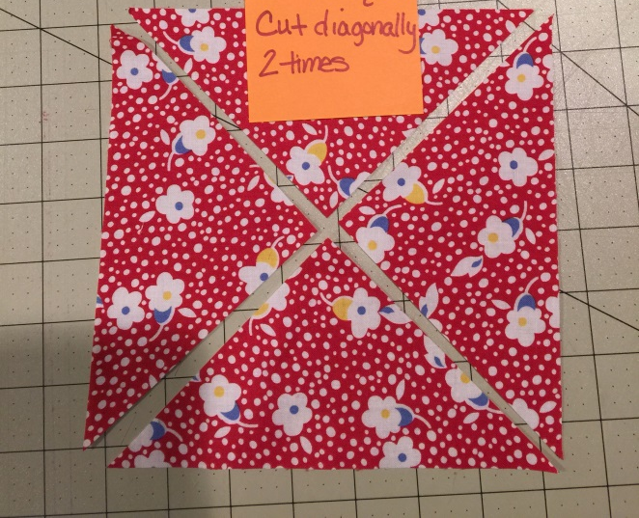
- Focus
  - 1 – 9” square
- Yellow
  - 2 – 7 ¼” squares
    - Subcut on diagonal 2 times to end with 8 triangles
- Brown
  - 3 – 7 ¼” squares
    - Subcut on diagonal 2 times to end with 12 triangles

- Green
  - 1 – 7 ¼” square
    - Subcut on diagonal 2 times to end with 4 triangles
- Food!
  - 2 - 6 7/8” squares
    - Subcut on the diagonal to end with 4 triangles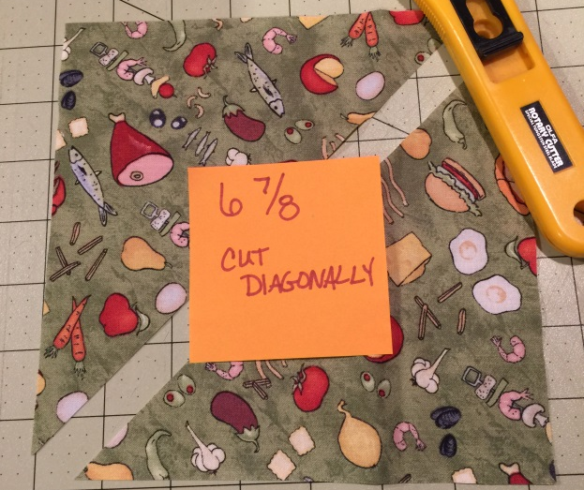

Sewing Instructions:
- Sew the Food fabric to the Focus fabric like so:
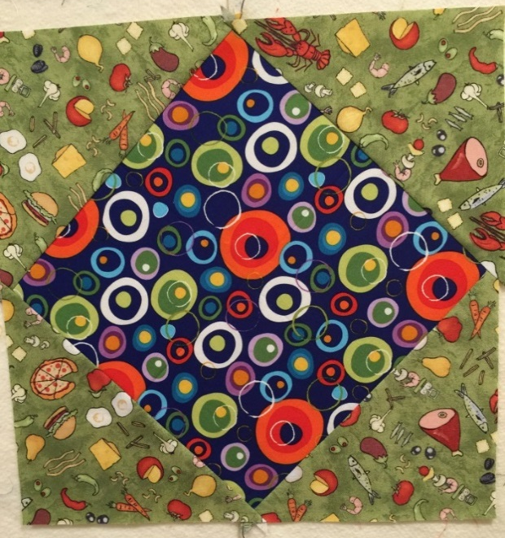
TIP: To help with lining up the triangles, you can iron a cease in the focus fabric. When you place the two pieces right sides together, line the triangle point up with the crease and sew.

- Using 4 green and 4 brown triangles, sew them together down the long sides. Press to the green.
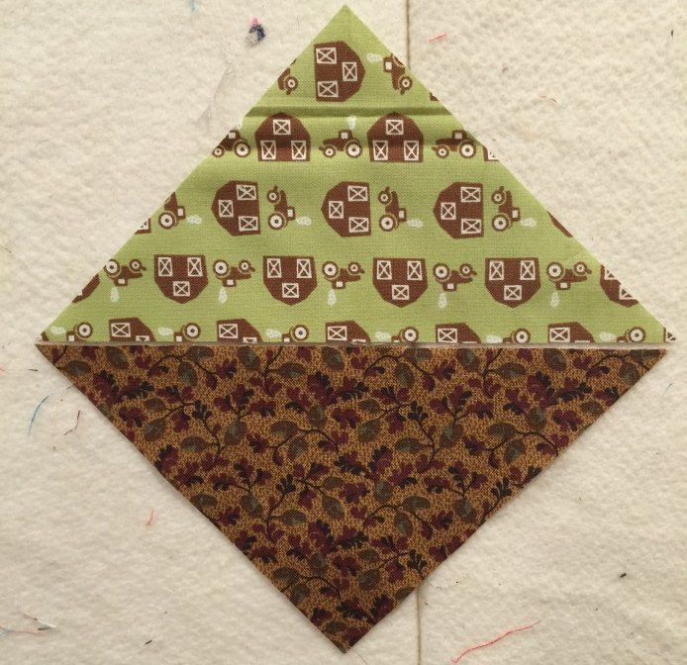

- Take 2 more of the brown triangles and sew them to either side of the green triangle. Press away from the center green triangle.
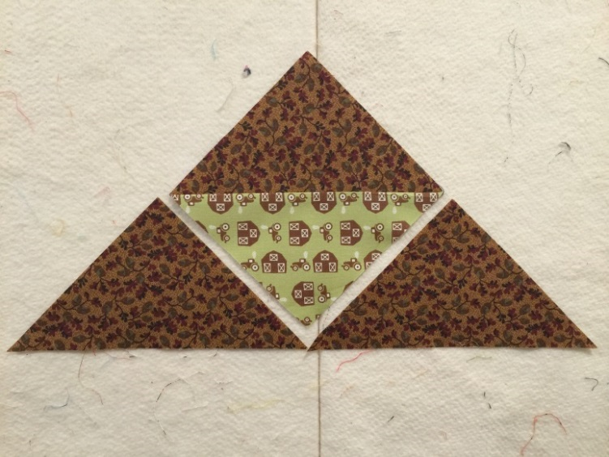
TIP 1: Cut your dog ears off so you have a right angle to start your sewing.
TIP 2: You can sew all of these without a visit to the ironing board! Just finger press the first triangle toward the brown and then sew on the second.

- Sew the yellow and red triangles into pairs. You need to watch the placement. You should have 4 units where the yellow is on the left and another 4 where it’s on the right. Press toward the red.
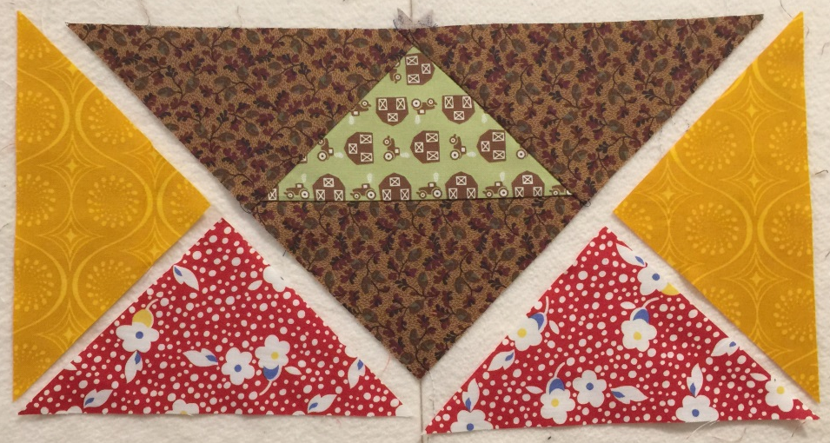

- Sew the yellow/red triangles to the short edges of the brown/green unit. If you pressed the right way, your center seams should nest perfectly. Line those up and toss a pin in there so your seams look all fancy.
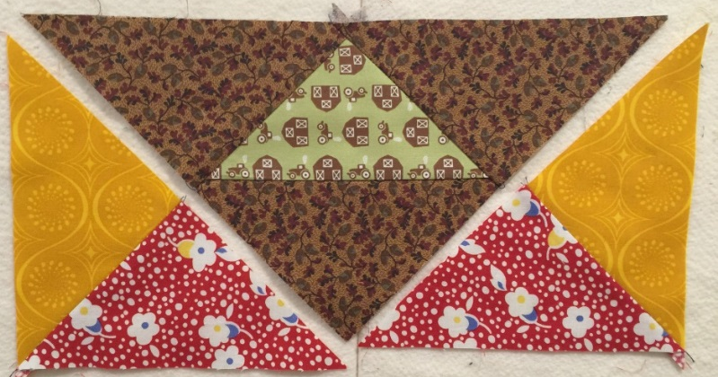

- Lay your units out like this and sew them into 3 rows of 3.Make sure you alternate the directions when you press so your seams nest nicely. 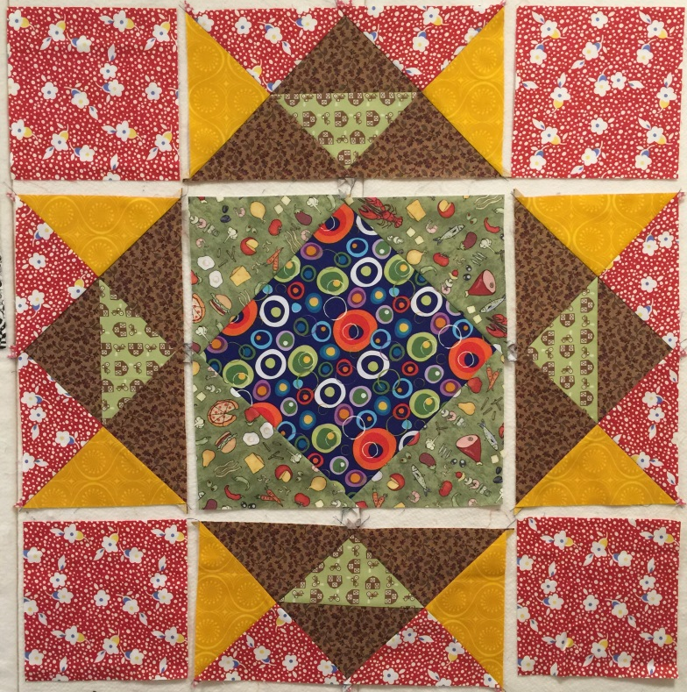
TIP 1: To get the center blue and side green points to meet properly, stick a pin through each point to line them up.
- Sew the rows together and you have a complete block! Hopefully it’s about 24” square.

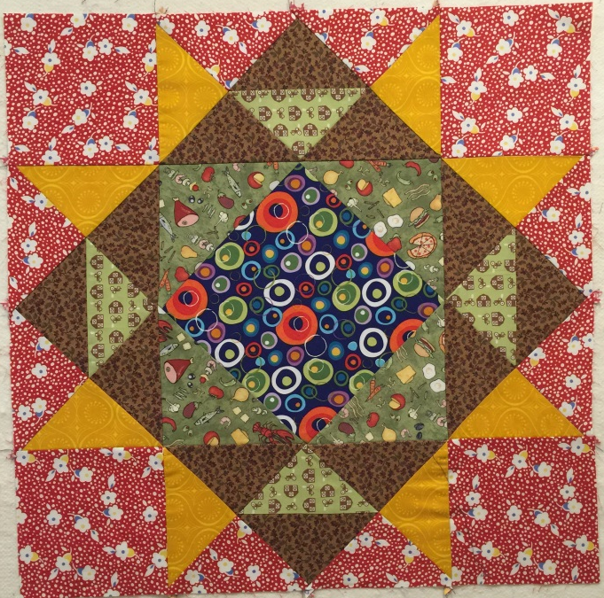
If you are only doing the Block of the Month, you are DONE! Hooray! If you’re ready to bring on the pain, continue below for mystery goodness.
For the MYSTERY Part A,
The approximate size will be 70x90. For yardage, the program I used was very vague. I used 15 fabrics and it said there was no more than a yard of each color. I can’t actually imagine that the quilt would use 15 yards but if you want to have some control over your strips, strings and blocks then you should start there.
If you would like all of the 2 ½” mystery strips to be a different color, you will need around 100 strips.
Cutting Directions:
- From 2 ½ inch strips:
  - 2 – 18.5” strips
  - 2 – 24.5” strips
  - 1 – 28.5” strip
  - 1 – 32.5” strip
Put these 2 ½ inch strips away! Don’t use them for piecing the next part.
- 2 – 4.5” squares from newsprint, phone book paper or similar.
- Fabric scraps wider than ¾”.
  - You can cut yardage, fat quarters or larger scraps into ¾, 1, 1 ½ and 2 inch pieces. Just make sure to vary the widths so your squares look super scrappy.
  - When I’m squaring off the fabrics I’m using for my quilt blocks, I cut a little wider strip off than usual so I can use it for my strip blocks.
  - These might take you a while so try just doing a few at a time. They aren’t all needed until the very end. If you like to work ahead though, this is the time! 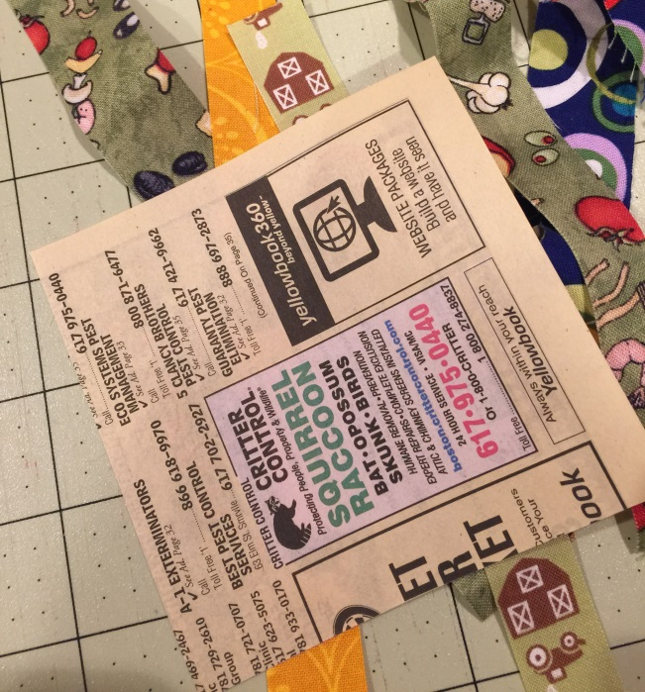
If you do not wish to piece your squares, you can simply cut 31 random colored 4.5” squares.

Piecing Directions for squares:
You may choose to do more than the 2 pieces needed for this part. In total, you will need 31 of these strip pieced squares.
Using scraps of fabric, cover the pieces of paper with diagonal strips. Start with one strip face up in the middle of the paper. Make sure it’s long enough to hang over the edges.
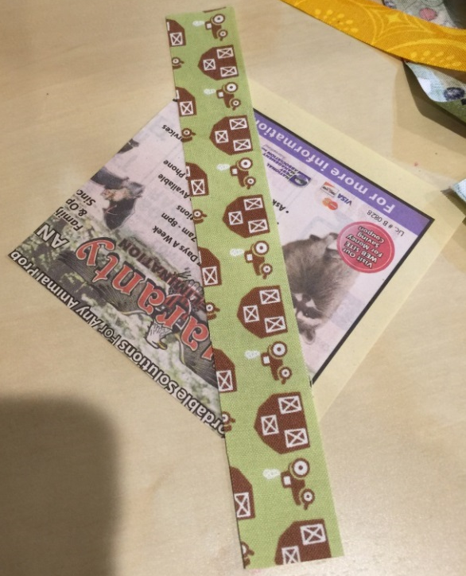
Add another placed on top right sides together. Sew. 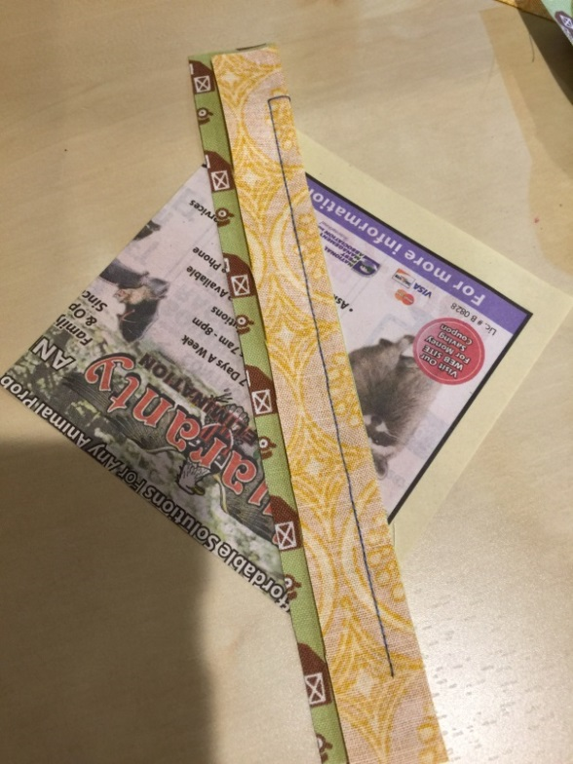

Finger press and select another strip. 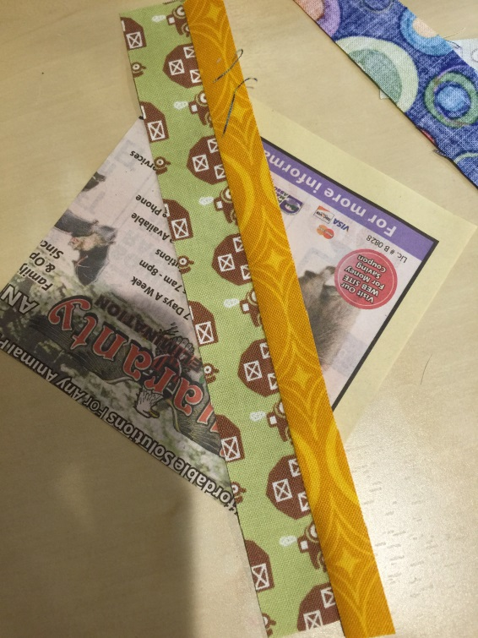
Continue sewing and flipping… 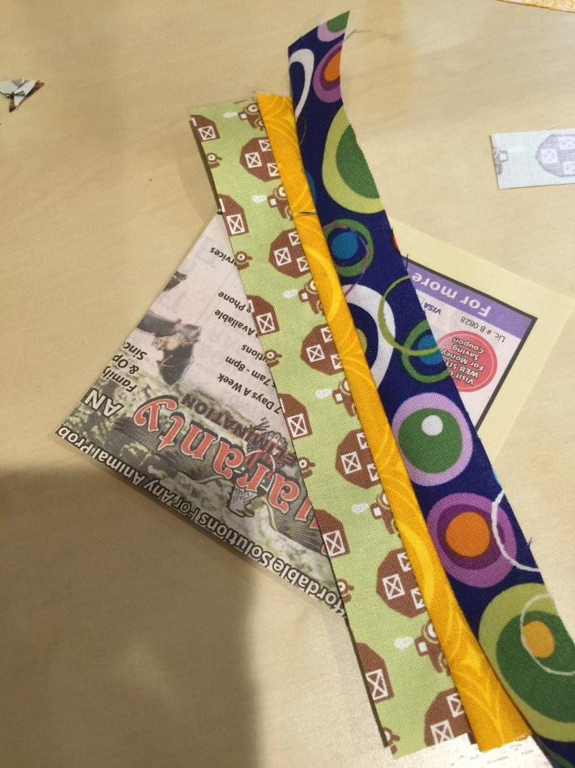

Until your entire paper is covered with fabric! 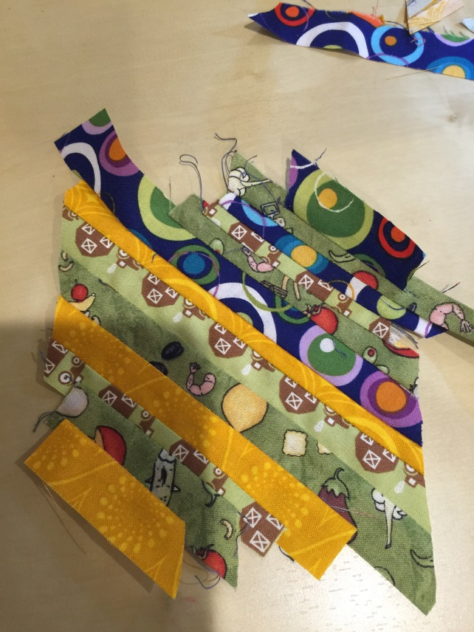
You shouldn’t see any paper from the front and the back side should look like this. Totally surrounded with bits!
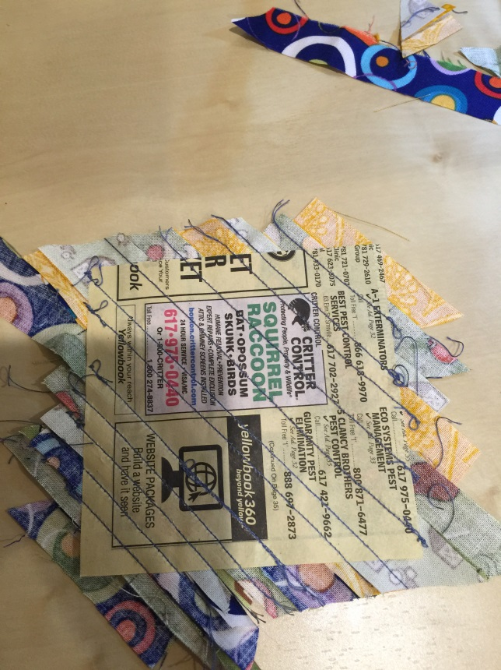
Now we trim it back down to 4.5 inches!
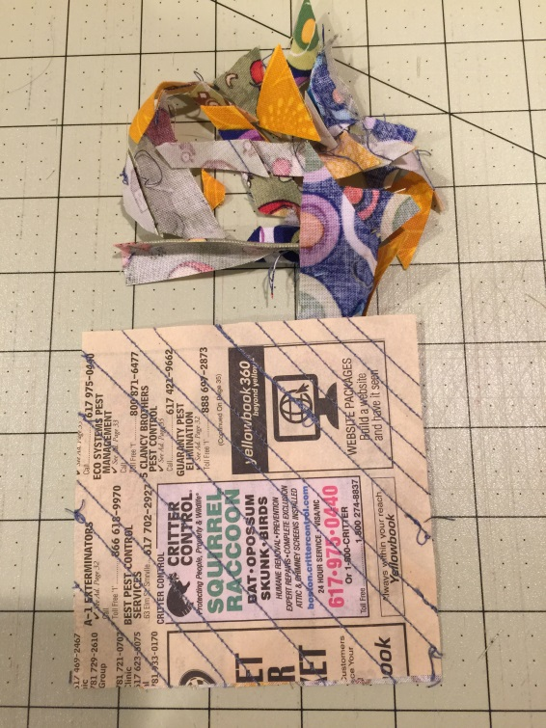
And then do it again!
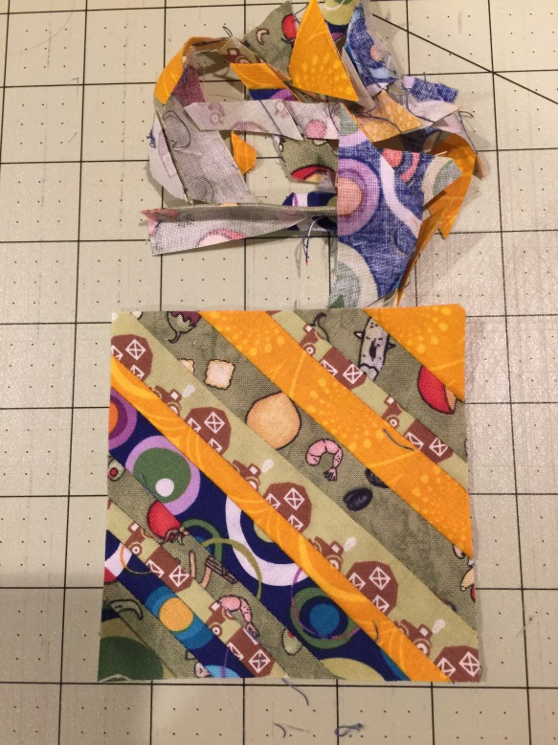
Place all of your cut 2.5” strips, 2 strip-pieced squares and the block in a bag marked Part A. Place the remaining squares in a “Mystery” bag. Remember to put it someplace “safe” so you’ll never see it again. I mean, so you’ll be able to find it again.

